Image | 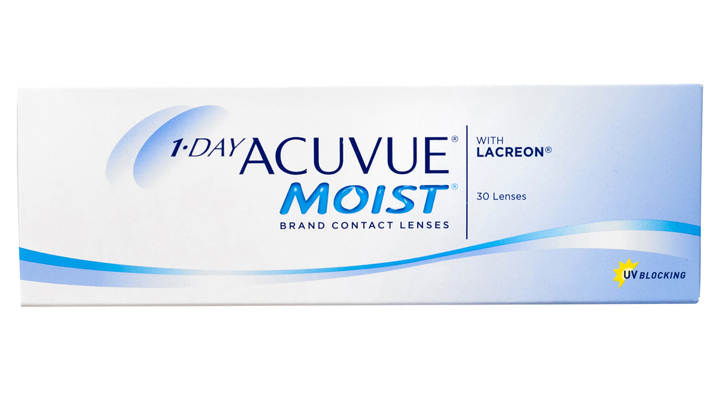
Brand | GUCCI
Model Name | 1-day-acuvue-moist
Price | RS 1499
PRODUCT DETAILS

